**Node.js console REPL :** Node.js comes virtual environment called REPL aka Node Shell. REPL means Read - Eval Print Loop. It is a quick and easy way to test simple node.js / JavaScript code.

To launch the REPL (node shell), open command prompt (in window) or terminal and type node.

You can now test pretty much any Node.js /JavaScript expression in REPL. For example if you write 10+20 then it will display the result 30 immediately in new line.

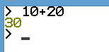

The + operator also concatenates strings as in browser's JavaScript.



You can also define variables and perform some operations on them.

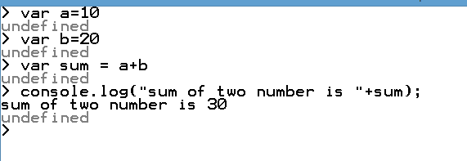

If you need to write multi line JavaScript expression or function then just press Enter whenever you want to write something in the next line as continuation of you code. The REPL terminal will display three dots(...), it means you can continue on next line. Write .break to get out of continuity mode.

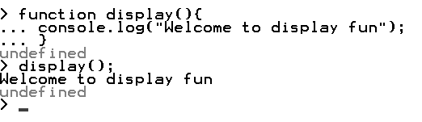

You can execute an external JavaScript file by writing node fileName command. For example, assume that demo.js is present in C or D drive go to that path

**welcome.js**

console.log("Welcome to Node.js Application")

To run this program

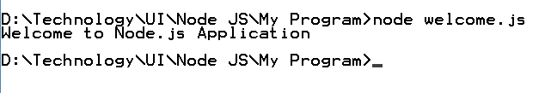

To exit from the REPL terminal Process Ctrl + C twice or write .exit and press enter.

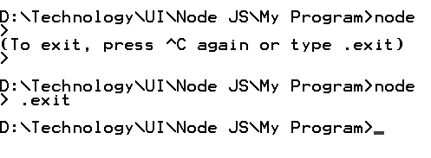

**.help command**

This command is use to display the help for the commands.

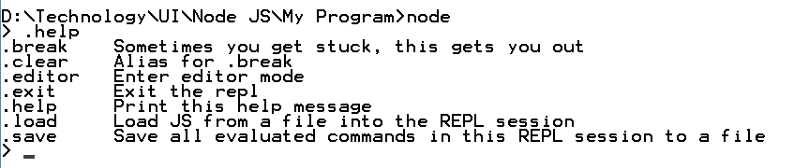

**tab keys :** Display the list of all commands.

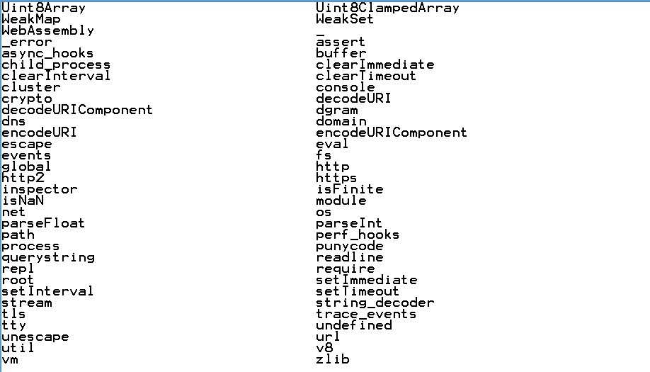

**.save fileName :** Save current node REPL session to file.

**.load filename :** Load the specific file in the current node REPL session.

**cntr + C =**  Exit from the REPL.

**.break :** Exit from multiline expression.

**.clear** : Exit from multiline expression